Vehicle Speed Estimation and Motion Saliency Tracking

Introduction
Motion analysis and vehicle speed estimation are critical tasks in traffic monitoring, autonomous driving systems, and intelligent transportation management. Traditional approaches rely on stationary sensors or radar systems, which are expensive and have limited coverage. Computer vision-based speed estimation offers a cost-effective alternative by leveraging optical flow tech- niques to track vehicle motion in video sequences.
This report presents an implementation of vehicle speed tracking and motion saliency de- tection using Lucas-Kanade Optical Flow combined with motion saliency maps. The system processes video sequences, identifies moving objects, tracks trajectories, and estimates real- time velocity in kilometers per hour (km/h).

Literature Survey

Optical Flow Fundamentals
The Lucas-Kanade method assumes that pixels in a small neighborhood move together (con- stant motion assumption). It solves the optical flow constraint equation using least-squares fitting over a window of pixels. It is computationally efficient and robust to noise.

Motion Saliency Maps
Motion saliency detection identifies regions exhibiting significant motion. Accumulated saliency maps provide temporal smoothing, reducing flickering artifacts and improving stability in track- ing results.

Vehicle Tracking and Speed Estimation
Motion-based speed estimation converts pixel displacement to real-world velocity using cali-
bration factors:

Speed =
Displacement × Scaling Factor ₍₁₎ Frame Time
where the scaling factor relates pixels to real-world distance and frame time is 1/FPS.

Problem Statement
Objective: Develop a robust system for real-time vehicle speed estimation and motion analysis in surveillance video sequences.
Challenges:
- Tracking vehicles despite appearance changes and occlusions.
- Distinguishing vehicle motion from camera jitter.
- Accurate real-world speed estimation from pixel displacement.

Methodology and Implementation

System Pipeline
Stage 1: Preprocessing
Resize frames to 512 pixels width and convert to grayscale.
Stage 2: Motion Saliency
Compute frame differences and accumulate: S_{t} = 0.9 × S_{t−1} + 0.1 × B_{t}.
Stage 3: Feature Detection
Uses cv2.goodFeaturesToTrack() with maxCorners = 200.

Mathematical Formulation
Motion Saliency Accumulation:
S_{t} = α · S_{t−1} + (1 − α) · B_{t} (2)
Optical Flow Constraint: Vehicle Speed Calculation:

I_{x}u + I_{y}v + I_{t} = 0 (3)

^{q}d² + d² × s
vkm/h = 3.6 ×

Output
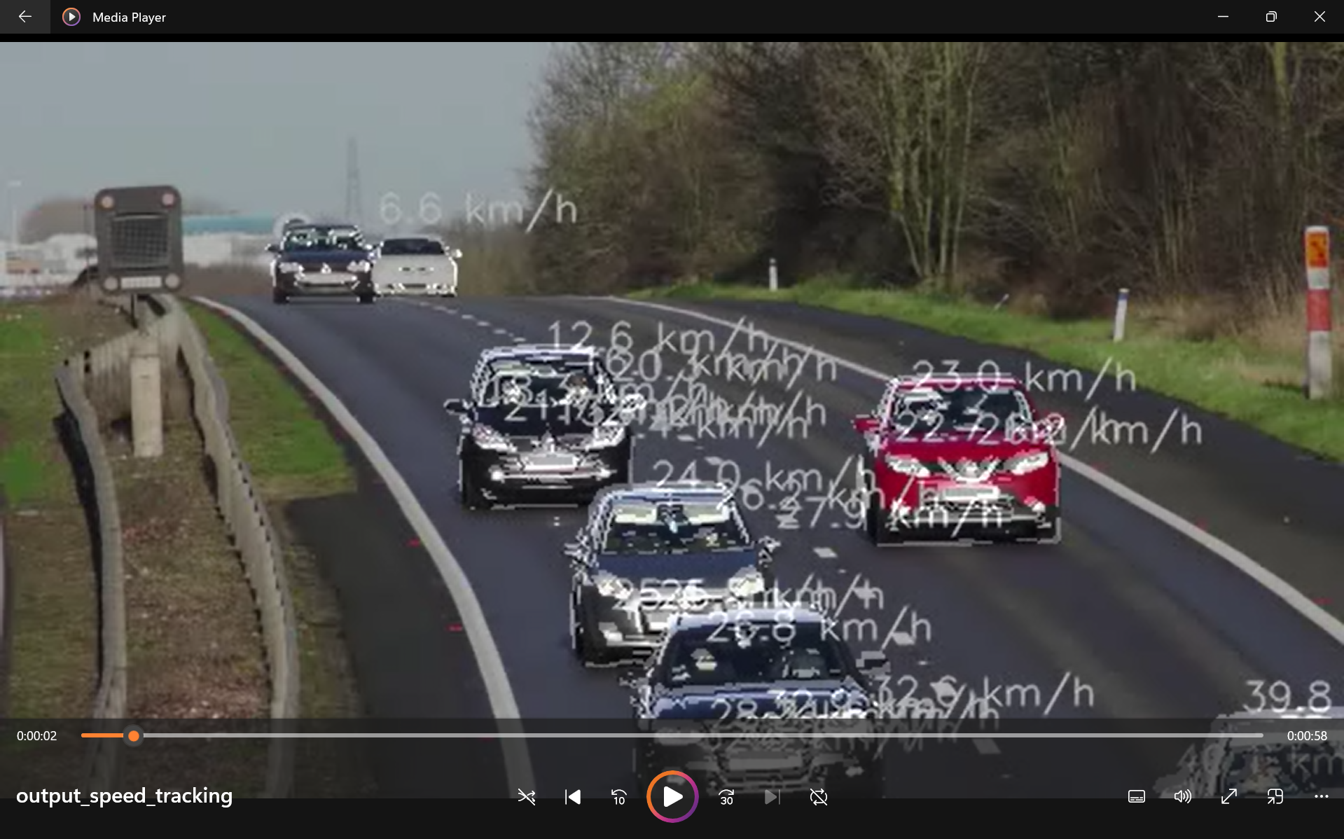
Fig 1: Speed Detection

Discussion & Conclusion
x y
1/f
(4)

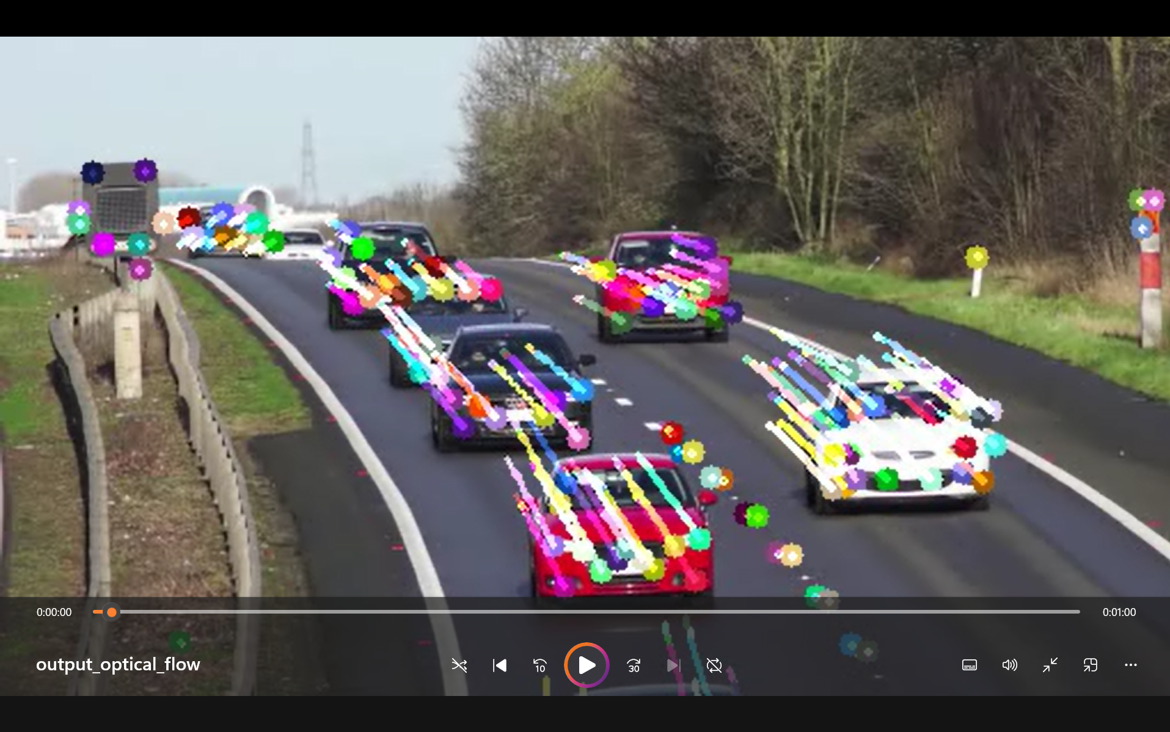

Fig 2: Optical flow Detection

The Lucas-Kanade optical flow method combined with motion saliency detection successfully captures vehicle motion patterns. The implementation demonstrates a lightweight, efficient alternative to deep learning approaches for real-time traffic monitoring. Future work will focus on perspective-aware speed correction and automated calibration.

References
- Lucas, B. D., & Kanade, T. (1981). An iterative image registration technique. IJCAI.
- Shi, J., & Tomasi, C. (1994). Good features to track. CVPR.
- Bewley, A., et al. (2016). Simple online and realtime tracking. ICIP.

